Woodland Avenue Practice
30 Woodland Avenue Luton, Beds LU3 1RW

Home Blood Pressure Readings
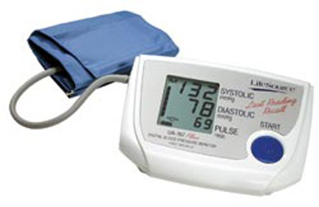

NAME:
DOB:

Please insert your BLOOD PRESSURE recordings below:

DATE | BLOOD  PRESSURE | PULSE
AM
PM
AM
PM
AM
PM
AM
PM
AM
PM
AM
PM
AM
PM
Do blood pressure 10am and 8.00pm or similar time each day; discard the 1st reading and record the second reading.
BP <140/80 normal, >140-150/80-90 Borderline, >150/90 High
www.woodlandavenuepractice.co.ukSR3/12

